  Name: | ___________________________________________________ |  | Date: ___________
Year 11 Applications
Test 6, 2019
Topics – Simultaneous Equations and Piece-wise functions

Total Time: | 46 minutes
Total Reading: | 2 minutes
Total Working: | 44 minutes
Weighting: | 8% of the year.
Equipment: | SCSA Formula Sheet; 1 page notes (A4 one side, Unfolded), CASIO ClassPad; Scientific Calculator, graph paper

44

= %

Resource Free Section – 13 min 1 min reading time [13 marks]

- [2 marks]
Solve each of these linear equations
- $\frac{4t+8}{6}=6$ b) $4n+12=3n+6$

- [3 marks:1, 2]
The cost of hiring a limousine for the Year 12 ball is $175 plus $3.50 for each kilometre travelled.
- Construct a formula to calculate the cost of hiring a limousine with this company

- Calculate the cost of hiring a limousine to travel 36km

- [5 marks:2, 3]
Solve the following simultaneous equations
a) | $$y=2x+6$$  $$y+3x=-4$$ | b) | $$3x+5y=-9$$  $$7x+4y=2$$

- [3 marks ]

Sketch the graphs of and x = 3 on the same set of axes, and use the graph to solve the simultaneous equations.
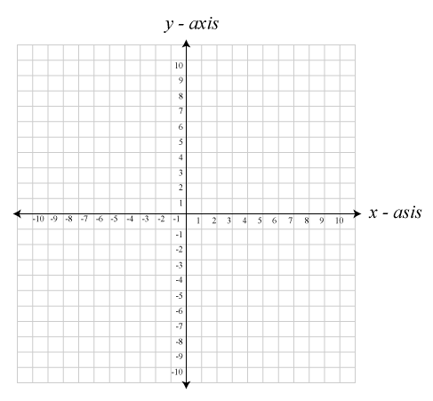

Solution:

-End of Resource Free Section-

Resource Rich Section – 31 min 1 min reading time [31 marks]

- [2 marks ]

Express the equation 3x + 6y − 18 = 0 in the form y = a + bx and hence state the gradient and y-intercept of the line.

- [3 marks ]

A taxi driver charges $15 flag fall and $5 per kilometre or part thereof. Construct a step graph to represent the taxi driver’s charges for the first 6 kilometres.

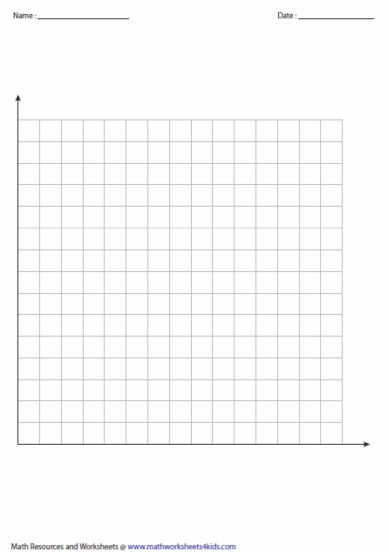

[11 marks; 2, 2, 2, 2 and 3]

To provide a lunchtime buffet, a catering company charge a flat fee of $150 plus an additional charge of $20 per person attending.
- Calculate the total cost charged by the catering company for a lunchtime buffet for 12 people.

- Complete the table below to determine the total cost ($C) of the buffet when n people attend.
 | Number attending (n) |  | 0 | 5 | 10 | 15 | 20 | 25
 | Total cost ($C) |  | 150 | 250
- Plot the points from the table on the axes below and join them with a dotted line.

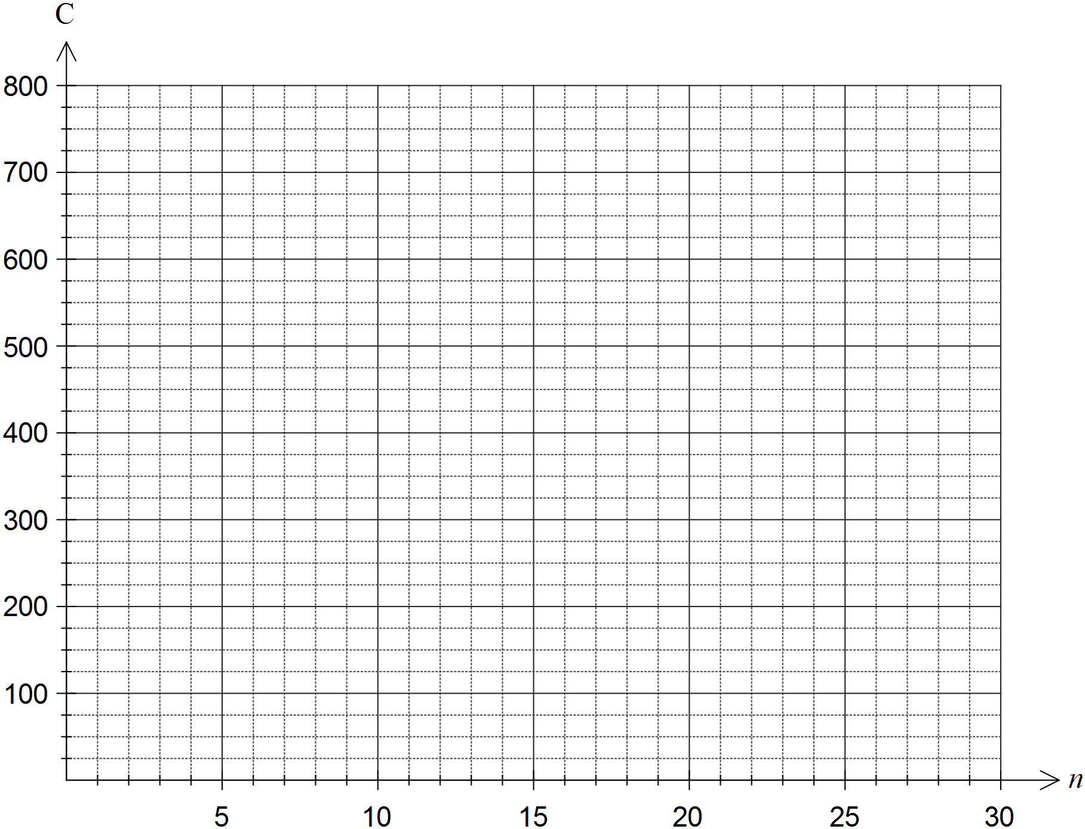

d) |  | Write a rule to determine the total cost, C, from the number of people attending, n.
e) |  | A business has a budget of $1 000 to hire the catering company to provide a lunchtime buffet. Determine the most number of people that they can invite to the buffet if they must not exceed this budget. Show your working.

- [2 marks ]

Find the equation of the line that passes through the points below
- (-1, 3) and (0, 4) b) (-2,-2) and (0, 2)

- [4 marks ]

To finish a project, Genevieve buys a total of 25 nuts and bolts from a hardware store. If each nut costs 12 cents, each bolt costs 25 cents and the total purchase price is $4.30, how many nuts and how many bolts does Genevieve buy?

- 9 marks [ 1, 2, 2, 4]

A piecewise linear equation is given below:
$$y=\left\{\begin{aligned}2x-5, -6≤x<1 \\ x-4. ≤x≤6\end{aligned}\right.$$

- How many line segments?

- What is the gradient of each line segment?

- Which line segment is steeper? Why?

- Sketch the graph of the piecewise linear equation given above, using additional graph paper

-End of Resource Rich Section-

